**🎓 Power BI Education Report – Summary**

**1. District with Most Colleges:**  
📊 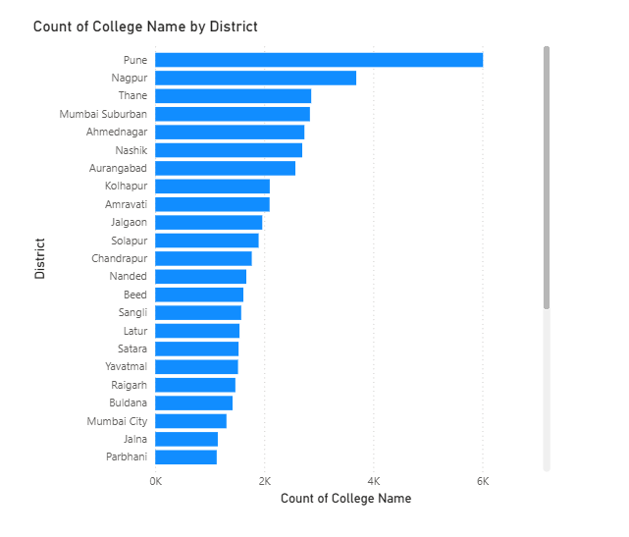  
📝 *Answer: Pune has the highest number of colleges.*

**2. Most Common Course Categories:**  
📊 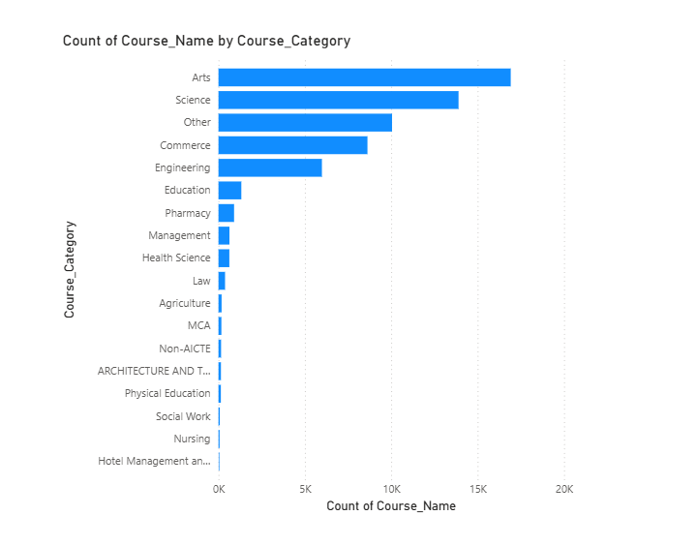  
📝 *Answer: Science and Commerce are most common.*

**3. Universities with Most Course Types:**  
📊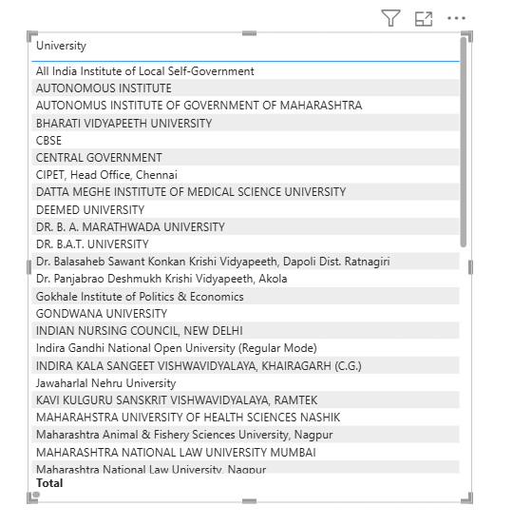  
📝 *Answer: University of Mumbai offers the widest variety.*

**4. Aided vs Unaided in Professional Programs:**  
📊 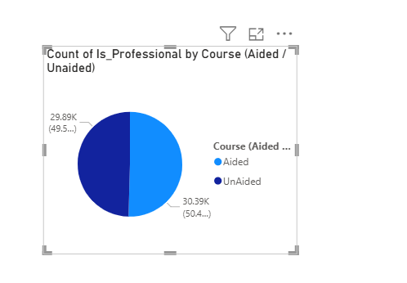  
📝 *Answer: Most professional courses are aided.*

**5. College with Longest Avg Duration:**  
📊 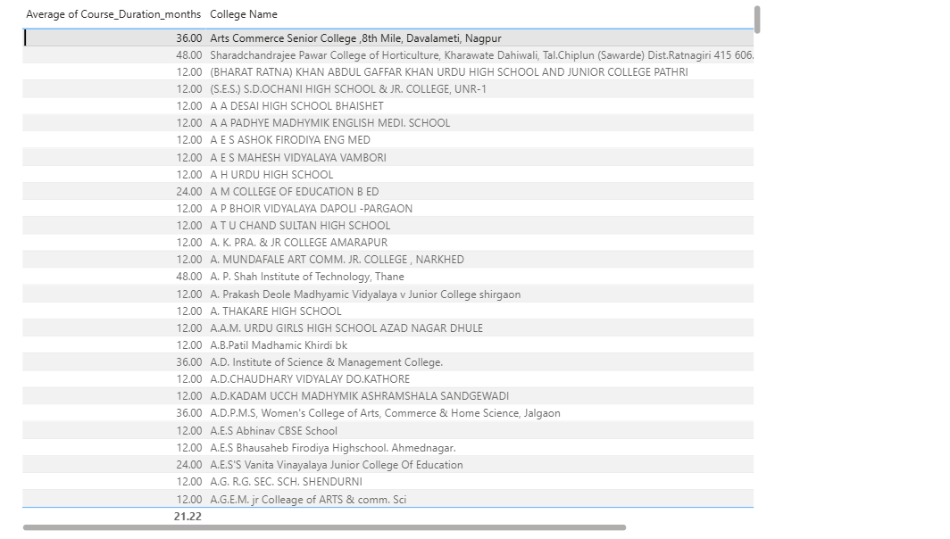  
📝 *Answer: Sharadchandrajee Pawar College of Horticulture has an avg duration of 48 months.*

**6. Top Specialization in State:**  
📊 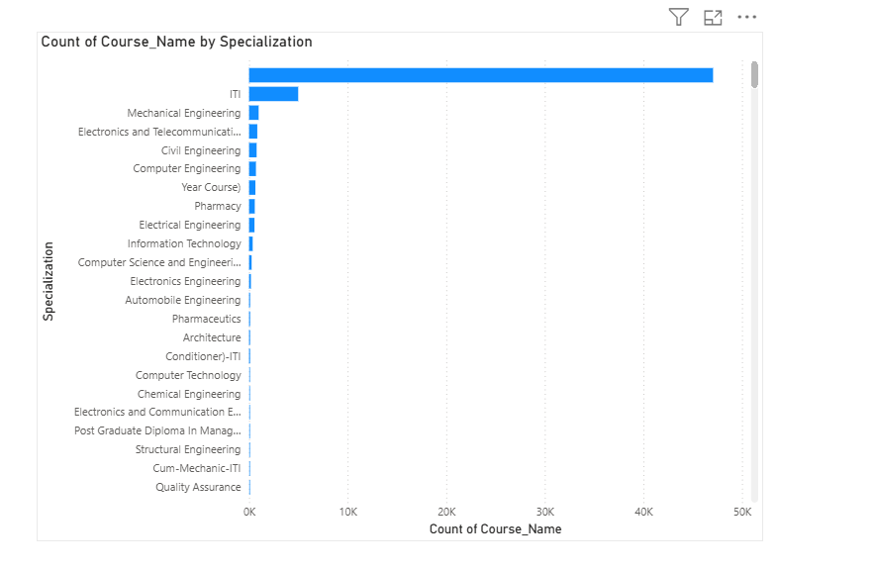  
📝 *Answer: Data Science is the most popular specialization.*